
Year 10
Pathway 10A

Mini Test
Trigonometry

Score: /17
Name: ____________________________ Total Time: 20 minutes

Show working and answers on this sheet. Show working in sufficient detail to support your answers. Incorrect answers without supporting reasoning may be allocated zero marks. Calculators may be used. 1 side A4 notes (handwritten) allowed.

- Find the value of $x$ correct to one decimal place in the following triangles.
(6 marks)

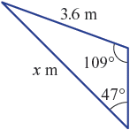

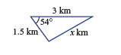

- Triangle ABC has ∠A = 50°, AC = 7 cm and BC = 6 cm. (4 marks)
Use the sine rule to find the value of ∠B, correct to one decimal place, given that:
- ∠B is acute

b) ∠B is obtuse

- A paddock ABC is fenced off as shown in the figure below.
(7 marks)
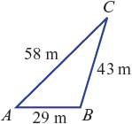

a Use the cosine rule to find the value of ∠A, correct to three decimal places.

b Hence, find the area enclosed by the fences, correct to two decimal places.

c The paddock is to be divided into two triangular paddocks by constructing a fence from point B to meet AC at right-angles at a point D. Determine how many metres of fencing will be required to construct BD to the nearest centimetre.

End of Test

